Hands-on Exercise No. 1 , DigiSkills 3 .0 Batch-04

Data Analytics and Business Intelligence
Request about Excersis:
Sir, I apologize for not completing this exercise using Power Query. Microsoft Office/Excel was not available on my laptop, and although I explored Google Sheets and Excel for the Web, the Power Query option was not available. Therefore, I completed the assignment using Excel formulas/rules so that I could submit it on time. I understand Power Query and will try to complete this exercise again using Power Query once Microsoft Excel is available on my laptop. Thank you for your understanding.

Tasks: 1
Identify and remove all duplicate records from the dataset using Power Query to ensure data accuracy and consistency.
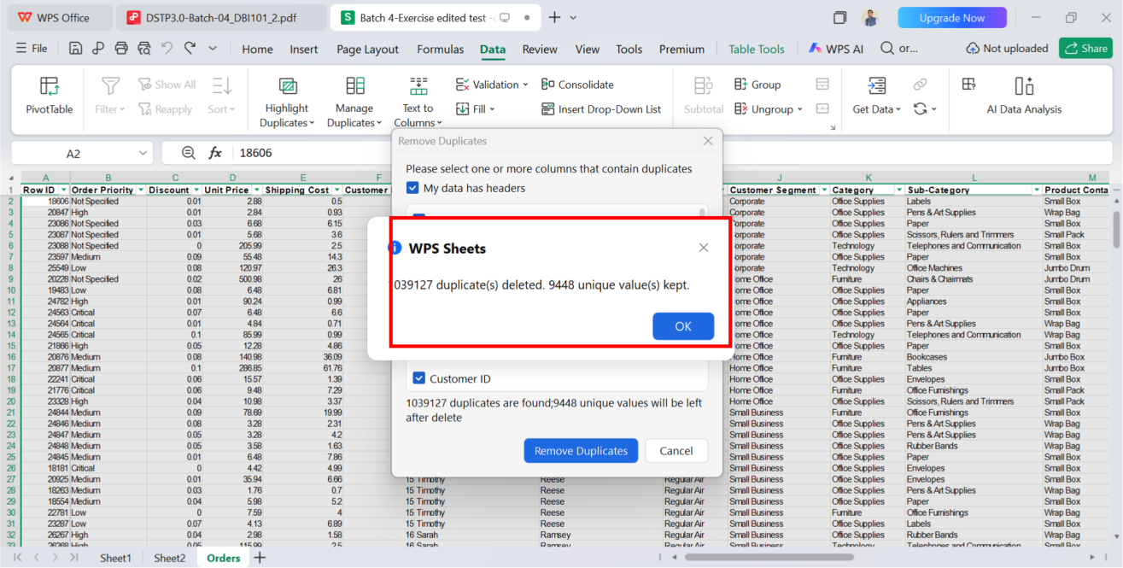
Screenshot:

Tasks: 2
Merge the First Name and Last Name columns into a single column named Full Name using
Power Query.
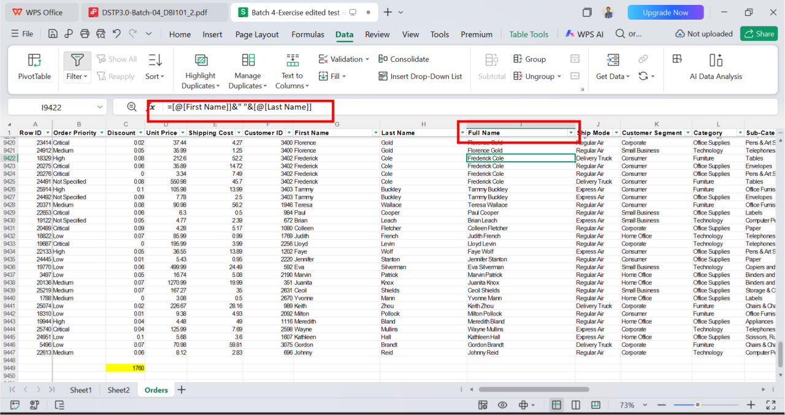
Screenshot:

Tasks: 3
Change the data type of the Ship Date column to Date using the Change Type with Locale
option. Select English (United States) as the locale to ensure the dates are converted correctly.
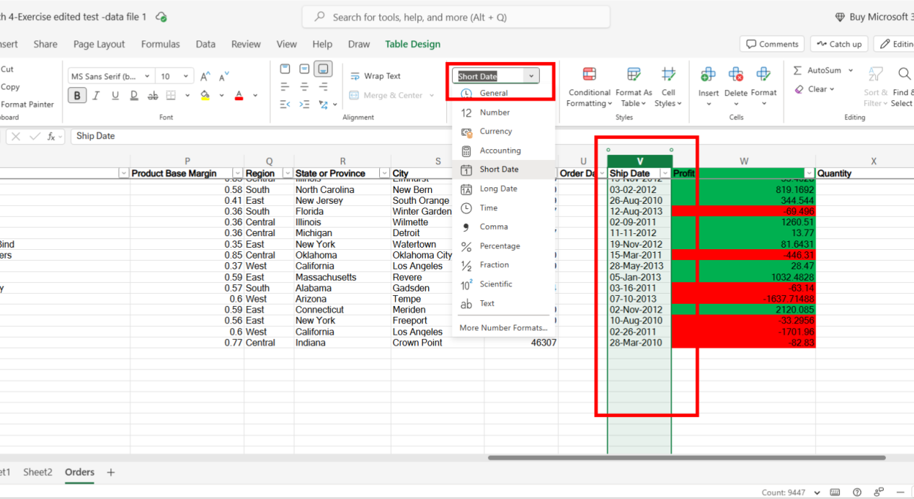
Screenshot:

Tasks: 4
Create a custom column in Power Query to calculate the number of days taken to deliver each
order using the Order Date and Ship Date columns. Name the new column Delivery Days.
Screenshot:

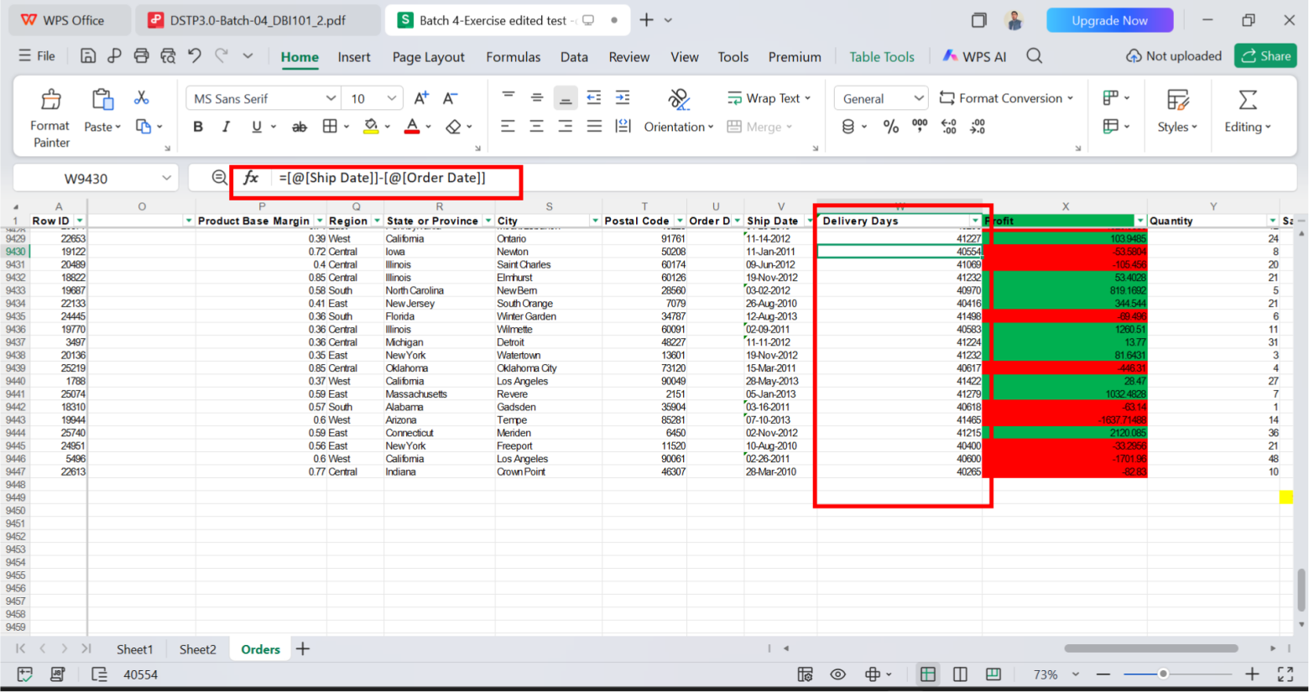

Tasks: 5
Create a conditional column in Power Query named Delivery Status to classify each order as
follows:
• Normal if the delivery was completed within 3 days.
• Late if the delivery takes 5 days.
• Delayed if the delivery took more than 5 days.
Screenshot:
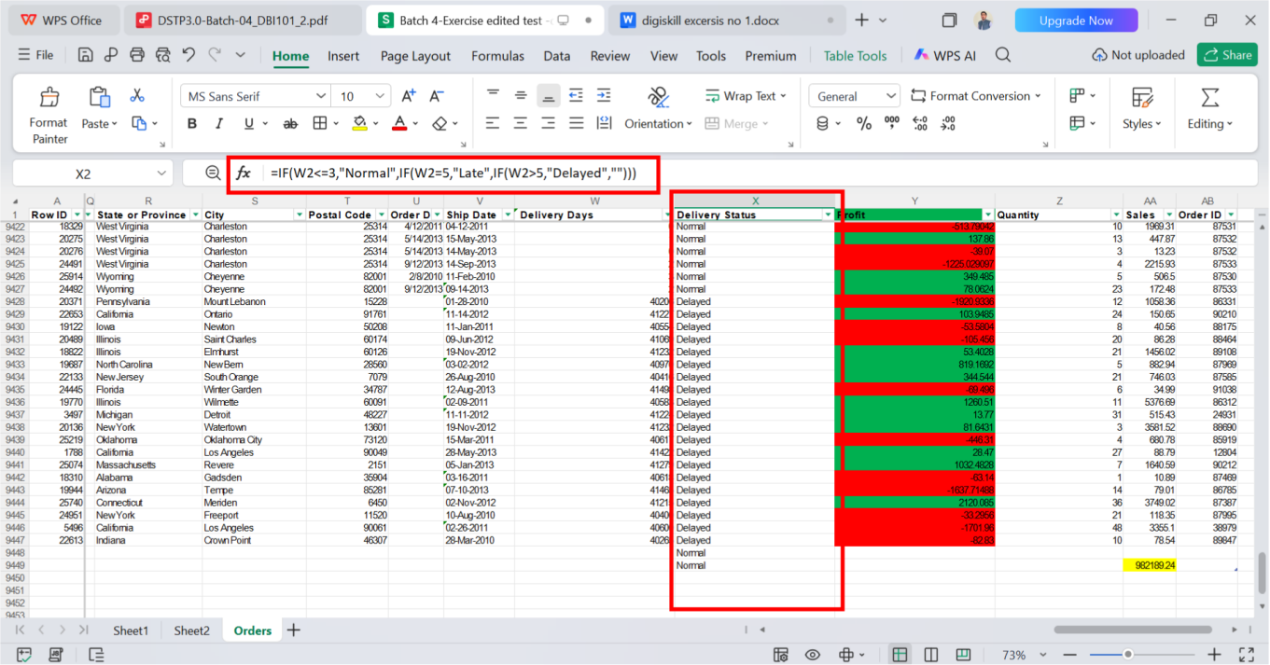

Thanks

